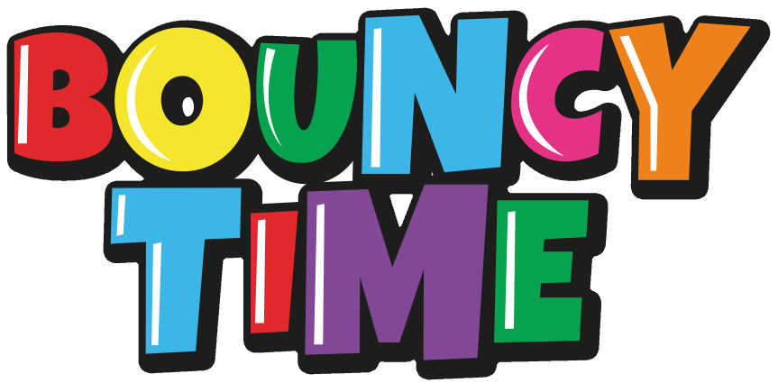

Risk Assessment for our Bouncy Castle

This is a SAMPLE risk assessment: we recommend that you use it to carry out your own risk assessment, which will include any other risks that are specific to your event, the location where you are holding it, or your users.
Putting up and taking down the Bouncy Castle
What are the hazards? | Who might be harmed and how? | Likelihood  - = not likely  - = likely  - = very likely | Level of harm  - = minor injury  - = moderate injury  - = serious injury | Action that will be taken to prevent this hazard | Responsible person who will make sure that action is taken

Bouncy Castle is very  heavy to lift and manoeuvre | Those who are transporting the bouncy castle, putting it up, or taking it down could injure their backs | 2 | 1 | At least two people will collect, lift or move the Bouncy Castle and the trolley will be used wherever possible  Advice will be given on correct lifting procedures to prevent injury (using guidance from www.hse.gov.uk or other sources).  At least two people will roll up the Bouncy Castle, following the instructions, and secure it with the strap provided
Long electric power cable | Those who are setting up other stalls at the event could trip on the cable | 2 | 1 | Secure the power cable to the ground as soon as it is laid down, and do not  remove the tape until cable is due to be wound up
What are the hazards? | Who might be harmed and how? | Likelihood  - = not likely  - = likely  - = very likely | Level of harm  - = minor injury  - = moderate injury  - = serious injury | Action that will be taken to prevent this hazard | Responsible person who will make sure that action is taken
Damage to the electric power cable | Anybody who touches the damaged cable could be electrocuted | 1 | 3 | Unroll the electric cable, and check the full length of the cable, plus any plugs or sockets  Ensure that the power cable is plugged into power supply that has a trip switch OR use the power breaker supplied
Heavy duty stakes to be driven in using mallet, and removed at the end of the day | Those banging in the stakes could hit their  hands  Others in the area could be hit with the mallet | 2  1 | 1  2 | Hold the stakes halfway down when banging them in  Knock the stakes sideways using the mallet before trying to pull them out Make sure the area is clear of other people
The Bouncy Castle is  wet when it’s put  away | Those rolling the Bouncy Castle up could be injured as it will be slippery and heavier if wet. | 2 | 2 | If possible, the bouncy castle will be dried out before it is pit away  At least 3 people will put away and lift the Bouncy Castle if it’s wet

Using the Bouncy Castle: At least two adults will supervise the Bouncy Castle at all times
What are the hazards? | Who might be harmed and how? | Likelihood  - = not likely  - = likely  - = very likely | Level of harm  - = minor injury  - = moderate injury  - = serious injury | Action that will be taken to prevent this hazard | Responsible person who will make sure that action is taken
Adults or older children jumping on the Bouncy Castle | Adults and older children could jump over the sides  of the castle  The seams of the castle could split causing it to deflate very quickly and injure all of those who are on it | 2 | 3 | The height restriction of 1.5m, and age restriction of 10 years, will be strictly enforced by those running the game
Larger children colliding with smaller children | Smaller children could be injured | 2 | 3 | Children will be grouped by age, and limited to 8 children at any one time
Children jumping off or falling off the front of the Bouncy Castle | Children could be seriously injured | 1 | 3 | Crash mats will be put down in front of the Bouncy Castle (please note, mats are not provided by the Resource Centre) At least one adult supervisor will be at the front of the Bouncy Castle at all times, and will ask children to move back if they come too close to the front of the Bouncy Castle
Children colliding with each other whilst on the Bouncy Castle | Children could be injured | 3 | 1 | Those supervising the Bouncy Castle will ensure that children do not bump into each other or become overly boisterous

What are the hazards? | Who might be harmed and how? | Likelihood  - = not likely  - = likely  - = very likely | Level of harm  - = minor injury  - = moderate injury  - = serious injury | Action that will be taken to prevent this hazard | Responsible person who will make sure that action is taken
Sharp objects that could puncture the  Bouncy Castle | Children on the Bouncy Castle could be injured by sharp objects on the Bouncy Castle or if the Bouncy Castle got punctured and deflated | 1 | 3 | The Bouncy Castle will not be set up on concrete or gravel and will be checked thoroughly before it is used  Children will be asked to remove their shoes and any other sharp objects before they go on the Bouncy Castle
Anchor points becoming untethered | The bouncy castle could move or tip, causing injury to the children on it, or anyone standing near it | 1 | 1 | The Bouncy Castle will not be put up if the wind exceeds Force 5, i.e. small trees sway (not just their branches) The Bouncy Castle will be tethered securely to the anchor points
Anchor points and other equipment around the outside of the Bouncy Castle (such as the trolley) | People could trip over any of these items and injure themselves | 1 | 1 | Those setting up the Bouncy Castle will mark off the blower area with fencing, hazard tape or cones
Bouncy Castle blower on ground near the  Bouncy Castle | People could trip over the blower and injure themselves, or cut off the power and cause the Bouncy Castle to deflate | 1 | 3 | Those setting up the Bouncy Castle will mark off the blower area with fencing, hazard tape or cones
Bouncy Castle gets wet | Children might slip and injure themselves | 2 | 2 | The Bouncy Castle will not be used if it rains, and will be dried completely before children are allowed on it  Food and drink will not be allowed on or near the Bouncy Castle
What are the hazards? | Who might be harmed and how? | Likelihood  - = not likely  - = likely  - = very likely | Level of harm  - = minor injury  - = moderate injury  - = serious injury | Action that will be taken to prevent this hazard | Responsible person who will make sure that action is taken
Using a petrol generator (the Bouncy Castle is supplied with an electric cable, but it can be used with a 3KVA generator) | If other appliances are run from the petrol generator there could be a reduction in power to the Bouncy Castle which could cause it  to deflate  The generator could catch fire, injuring those near it | 2 | 3 | No other appliances will be plugged into the generator  A fire extinguisher will be kept near the petrol generator
People going on the Bouncy Castle after the event has finished and it is not longer being supervised | People could disregard the guidelines for safe use of the bouncy castle, and injure themselves or others. If they were injured, there may not be anyone nearby to help them. | 2 | 3 | The bouncy castle will be supervised all the time that it is inflated, and will be taken down as soon as possible after the event has finished.

